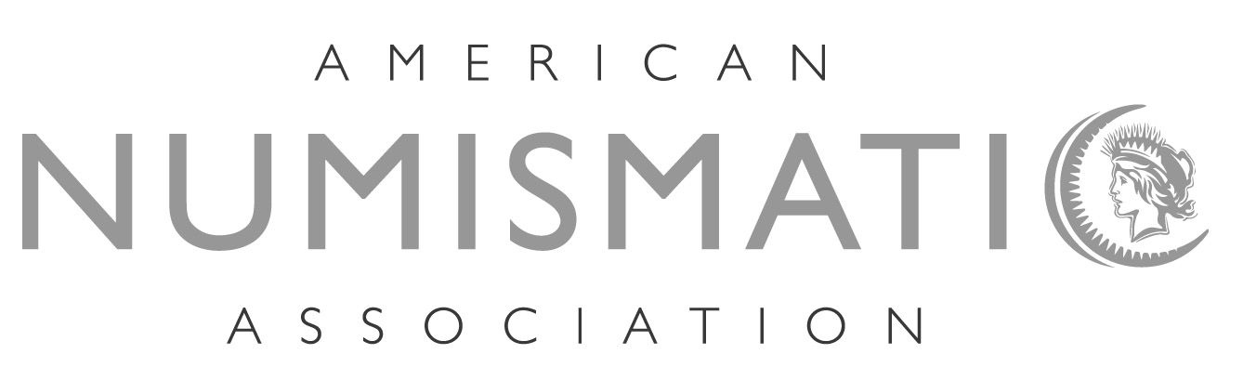

NOMINEE OUTLINE

ELECTION YEAR: 2015
CONVENTION: Chicago – 124th Anniversary Convention
CONVENTION DATES: August 11-15, 2015

The individual nominee assumes all responsibility for meeting the deadlines noted below. The ANA assumes no responsibility and will not notify nominees of approaching deadlines.

November 2014 “Call tor Nominations” in November 2014 through
February 2015 issues of The Numismatist.

December 1, 2014 Only nominations submitted in writing to the Executive
Director received no earlier than December 1, 2014, and no later than by March 1, 2015, will be accepted. Nominations received prior to December 1 and after March 1 will be deemed invalid.

An individual wishing to be nominated must ensure that he/she has the required 25 nominations from any combination of member clubs in good standing or individual members in good standing.

As individuals attain "nominated" status, the Executive Director will send a “Notice of Nomination" by certified mail, return receipt requested.

March 31, 2015 Written notice of acceptance or declination of nomination, along with a photograph and biography/ platform of the nominee (not to exceed 350 words) must be received by March 31, 2015. If these items are not received, the photograph, biography and platform will not be published in The Numismatist.

June 1, 2015 Official election ballots will be sent by the independent auditing firm on or before June 1, 2015, to all members entitled to vote. Included is a self-addressed, return envelope, and candidate biographies/platforms.

July 1, 2015 Completed ballots must be received by the independent auditing firm on or before July 1, 2015. Ballots received after this date will not be counted.

July 15, 2015 The independent auditing firm must deliver a report of votes cast for each candidate to the President and Executive Director no later than July 15, 2015.

July 16 - Aug 1, 2015 At least 10 days prior to the opening day of the anniversary convention, the Executive Director, by written and/or electronic communications, shall announce to all candidates and to members of the numismatic media who customarily receive announcements from the Association the number of votes obtained by each candidate for each office.

