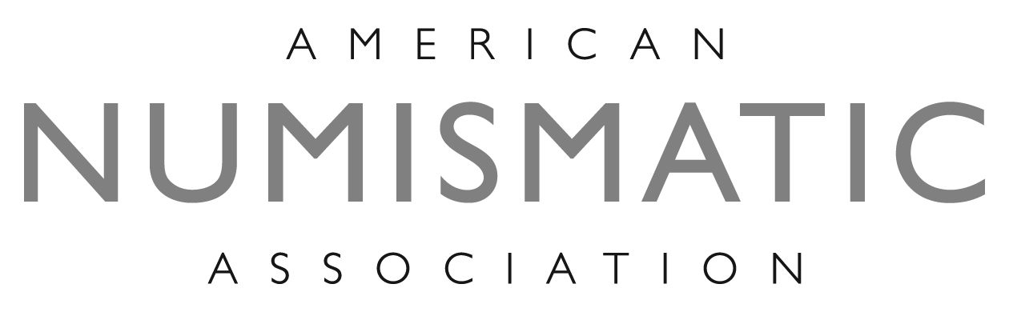

ELECTION BASICS

GENERAL INFORMATION

The American Numismatic Association is a nonprofit, educational organization and is recognized under the Internal Revenue Service Code as a 501(c) (3) tax-exempt organization. It is governed by a nine-member Board, which includes a president, vice president, and seven governors at large. The ANA's federal charter, granted in perpetuity by the United States Congress, rests control of the Association in the hands of this Board.

In 2015 the terms of all nine officers will expire. Those elected will be installed at the ANA's 124th Anniversary Convention in Chicago, IL, August 14, 2015 and will compose the Board of Governors for the next two years.

ANA members with voting privileges can nominate candidates for the ANA Board of Governors. Nominations must be in writing and received by the Executive Director no earlier than December 1, 2014, and no later than March 1, 2015.

Individual members 13 years of age or older as of March 31 of an election year and who have been members of the Association for at least one year as of that date shall be entitled to vote in any Association election. ANA-member clubs are entitled to one vote.

ELIGIBILITY TO HOLD OFFICE

Members 18 years of age or older as of March 31 of the election year and who have been a member of the Association for at least three consecutive years as of that date shall be eligible to hold elected office.

In order to be a candidate for office, a member must receive at least 25 nominations from member clubs in good standing and/or individual members in good standing. No member may nominate himself or herself or nominate a number of candidates for any office in excess of the number to be elected to an office. This means each individual member or club is allowed to nominate one person for president, one for vice president and seven for governor.

ELECTION ADVERTISING
Election advertising will be accepted for the March, April, May and June 2015 issues of The Numismatist. In accordance with ANA bylaws, campaign advertising must include the full name and ANA member number of the sponsoring individual (whether that is you or another ANA member). If the sponsor is a committee or organization, the advertisement must include the name, address and member number of its chairman or principal representative. (This requirement applies to election advertising in all numismatic publications.)
Advertising copy, as well as all photographs, artwork or electronic files for The Numismatist, is due the 20th of the month, two months preceding the cover date of the desired issue. The ANA Publications Department can design and produce your ad for The Numismatist at no charge.
For ad specifications and prices, contact Sales Manager David Truesdell at
719-482-9847, e-mail truesdell@money.org.

CLUB MAILING LABELS

If you would like to reach or otherwise contact the ANA’s member clubs (approximately 450), you can purchase club mailing labels for $100 (one-time use). Labels will not be sent until payment is received. Please make checks payable to the American Numismatic Association.

CANDIDATE BIOGRAPHIES AND PHOTOGRAPHS
In accordance with ANA bylaws, each candidate for ANA office must furnish a biographical sketch and platform, not exceeding 350 words in length, for publication in The Numismatist. The biography should include the candidate's record of service to the Association and to numismatics in general. This material will be published in the June 2015 issue of The Numismatist and will be enclosed with ballots mailed to all voting members.
All biographical information and platforms must be typed using upper-and lower-case characters and submitted via e-mail to election@money.org or mailed on CD (accompanied by a letter-quality printout) to the Executive Director at 818 N. Cascade Ave., Colorado Springs, CO 80903. Copy submitted by fax cannot be accepted. Please submit a professional-quality, color portrait no smaller than 4 x 5 inches (300 dpi). All material must be accompanied by the candidate's member number and name (as he or she wishes it to be printed), as well as his or her address, telephone number and e-mail address (not for publication).
Any submission that is more than 350 words in length will be edited by deleting text from the end of the document. Candidates will not receive a proof copy prior to publication. Deadline for receipt of these materials is March 31, 2015. Only those biographies, platforms and photographs received by this date will be published in The Numismatist and sent with the official ANA ballot.

